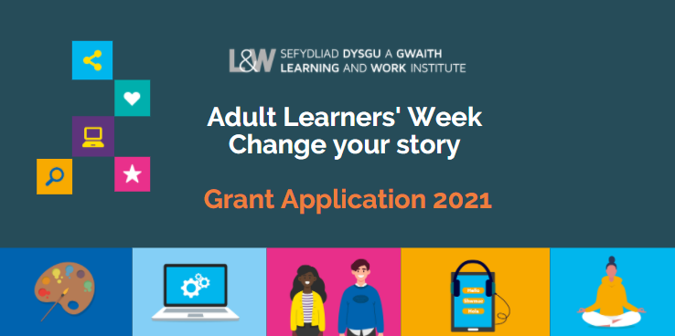
About the campaign (20 – 26 September 2021)

We want everyone to realise their ambitions and potential in learning, work and throughout life. Promoting lifelong learning and skills is a crucial part of the work we do with partners and stakeholders across Wales.

Adult Learners’ Week is an annual campaign which celebrates and promotes learning opportunities. In 2021 the campaign will run from 20 – 26 September.
Adult Learners’ Week gives individuals the chance to take a step towards developing their skills; whether they want to get a better job, build confidence to access a course, pursue a special interest or do something to support their wellbeing. The festival provides an umbrella to promote formal and informal opportunities and to celebrate lifelong learning.
This year, while we adapt and recover from the coronavirus pandemic, the Adult Learners’ Week festival will promote a mix of online courses, tasters, and tutorials as well as some face-to-face community outreach events, and blended delivery if appropriate within the current restrictions.
This fund offers support for providers of adult learning to develop and deliver content for the campaign. Activity can be delivered throughout the month of September 2021.
Grants of up to £750 are available to organisations working in Wales who deliver lifelong learning. This grant fund is intended to support the creation of free bitesize tasters, learning events, outreach activity, masterclasses or podcasts and to develop content that can be adapted to an online environment.

You may also be interested in delivering online/face to face Open Days – these should be focused on learning for adults. We are also interested in family learning and particularly to support individuals or communities who have been particularly challenged over the last year.

We are interested in activity that tackles barriers to participation and to promote equity and inclusion. For example, you may want to focus on activity particularly for disabled people, people who are seeking asylum or are refugees.

We are keen to see opportunities really targeted at those who have low levels of skills or qualifications.

We are interested in activity working in partnership with health care to tackle health inequalities and to recognise the role of learning and skills as part of the solution.

We are interested in activity that builds on the enthusiasm of existing learners as advocates to encourage their own communities to take part.

The deadline for applications: Monday 5 July 2021

Please send your completed form to: alwevents@learningandwork.org.uk

Guidance

Grants can be used to:
- Create online/face to face bite size tasters
- Deliver live online events and sessions
- Co-ordinate online/face to face open days for community based, family and adult learning opportunities
- Support creative ideas to reach more adults and families with learning opportunities or to engage with information, advice and guidance
- Enable partnership activity to reach new audiences, test news ways of working or find new ways of promoting/delivering opportunities to reach those who need most support
- Build more blended learning activity and support innovation in distance learning strategies
- Focus on mental health and wellbeing by creating more opportunities for informal learning opportunities
- Enhance inclusion by focusing on digital skills and access

All activity must be uploaded to the Adult Learners’ Week platform and should be available for September 2021, with a particular focus for Adult Learners’ Week from 20 - 26 September 2021.

The Grant Fund cannot be used for:
- Research projects
- Already established courses
- Hardware – such as Laptops and/or iPads

At Learning and Work Institute, we believe that the Adult Learners’ Week campaign and messages are stronger across Wales if all partners utilise the same branding. You will need to use the campaign branding for your specific event:

- Online presence (websites)
- Social media strategies (Twitter, Facebook, Instagram, YouTube)
- Any other digital marketing
You will also be required to complete a full Evaluation form after your events take place.

Application Form

Your contact details:

Name
Organisation/ Partnership
Address
Email
Phone

Grants of up to £750 are available: Please supply a clear budget showing detailed costings of planned expenditure and how much you are applying for. Please only apply for what you need as we’d like to spread available funding across as many organisations as possible.
Tell us about your activity/proposed project - please describe what are you developing?

What broad category does your activity fall into? (Please tick the subject areas that apply)

- Construction and Trades
- Digital skills
- General Education
- Health, Wellbeing and Exercise
- Job skills
- Languages and communications
- Life skills
- Making and creating
- Outdoor activities and the environment
- Reading, writing and maths
- Science, technology and engineering
- Social Sciences and Humanities

Please provide an easily understandable name of the event / course and the length (e.g. one-off or 6-week) and confirm who is delivering it?
Please tell us who are you targeting and why? For example, who it is suitable for; what people will/ should get out of it; how long the commitment is. Max 250 words.

If the event / course will be online, which platform will your session be hosted / delivered on? (For example, Zoom Webinar or Facebook Live)

How else will you promote your event or course other than the Adult Learners’ Week website?

Are you able to upload the event / course listing in Welsh and English on our Adult Learners’ Week website?

- Yes

- No
Please give details of Social media handles (Facebook, Twitter, Instagram and YouTube)
Facebook link | www.facebook.com/
Twitter handle | @
Instagram handle | @
YouTube link

There will be a media campaign to promote the Adult Learners’ Week platform and Adult Learners’ Week activity, in addition to this, please describe how you will promote your activity other than listing it on the Adult Learners’ Week website and how you will measure the impact and evaluate the effectiveness of your activity?

  - Target numbers set and attendance tracked / achieved per activity
  - No of people enquiring about further learning and/or enrolling on a course
  - No of website clicks
  - No of views
  - No of new likes and followers on Twitter/Instagram/ Facebook
  - Learner feedback and testimonials
  - Any other feedback

Please read carefully and confirm the following:
- If I am successful in this funding application, I am aware that I must keep Learning and Work Institute up to date with any changes with my events and information, and ensure that we can maximise partnership and promotion (please tick)

- I am aware that a condition of the grant is to upload / update my event details onto the campaign website bilingually by 27 August 2021 and for an Evaluation form to be submitted - post event, in full in order to ensure payment of the grant (please tick)
- We would like to keep you informed, by email, about further Learning and Work Institute events, conferences, and our campaigning work in Wales.

Deadlines: Next Steps

The deadline for applications: 5 July 2021

Successful applications will be notified from week commencing 12 July 2021.

If you have any queries about your application, please do not hesitate to email alwevents@learningandwork.org.uk

Successful applicants must submit the following:
- We expect all event information to be uploaded bilingually onto our online platform
- A fully completed online evaluation report which will provide sufficient evidence and reporting on all areas of the original application must be submitted by the end of September 2021.

