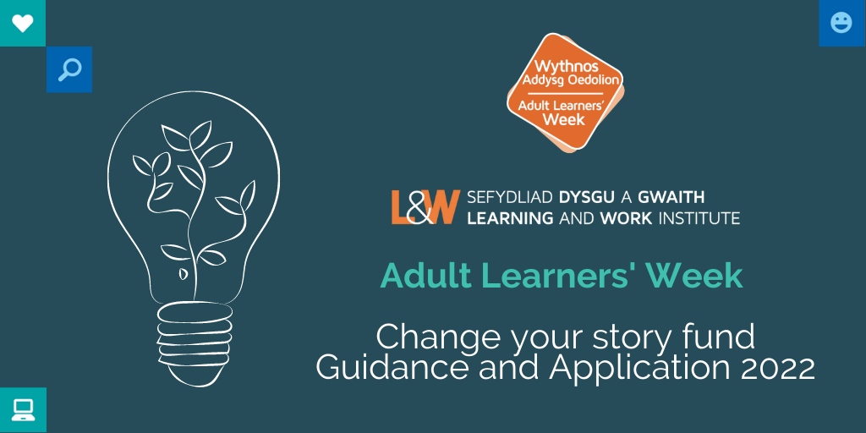
About the campaign | 19 – 25 September 2022

This document is available in Welsh.
We want everyone to realise their ambitions and potential in learning, work and throughout life. Promoting lifelong learning and skills is a crucial part of the work that we do with partners and stakeholders across Wales.

Adult Learners’ Week is an annual campaign which celebrates and promotes learning opportunities for everyone. The campaign will run from 19 – 25 September 2022.
Adult Learners’ Week provides a focus to promote formal and informal opportunities and to celebrate lifelong learning. We want to showcase steps back to learning and opportunities to develop skills – for work, to support families, for wellbeing and quality of life.
This year, while we adapt and recover from the coronavirus pandemic, the Adult Learners’ Week festival will promote a mix of online courses, tasters, and tutorials as well as face-to-face community outreach events, and blended delivery if appropriate.
This fund offers support for providers of adult learning to deliver content and outreach promotional activity for the campaign period and throughout the month of September 2022.
Grants of up to £750 are available to organisations working in Wales who deliver lifelong learning. This grant fund is intended to support the creation of free bitesize tasters, learning events, outreach activity, masterclasses, learner voice and to develop content that can be adapted to an online environment. You may also be interested in delivering online/face to face Open Days – these should be focused on learning for adults. We are also interested in family learning and particularly to support individuals or communities who have been particularly challenged over the last year.

We want you to think about tackling barriers to engaging adults and families and inspire more adults to find out what is available to support their learning journey and build their confidence to start.

We are interested in activity that:
- Tackles barriers to participation and to promote equality and inclusion.
- Focuses on people with low levels of skills or qualifications
- Creates partnerships with health care to tackle health inequalities and to recognise the role of learning and skills as part of the solution to live a better life
- Builds on the enthusiasm of existing learners as advocates to encourage their own communities to take part.
The deadline for applications: 8th April 2022

Please send your completed form to: alwevents@learningandwork.org.uk

Guidance notes – please read carefully
Grants can be used to:
- Create online/face to face bite size tasters
- Deliver live online events and sessions
- Co-ordinate online/face to face open days for community based, family and adult learning opportunities
- Support creative ideas to reach more adults and families with learning opportunities or to engage with information, advice, and guidance
- Enable partnership activity to reach new audiences, test news ways of working or find new ways of promoting/delivering opportunities to reach those who need most support
- Build more blended learning activity and support innovation in distance learning strategies
- Focus on mental health and wellbeing by creating more opportunities for informal learning opportunities
- Enhance inclusion by focusing on digital skills and access

All activity must be uploaded to the Adult Learners’ Week platform and should be available for the start of September with a particular focus for Adult Learners’ Week from 19 - 25 September 2022. Funding will only be used for activities throughout September.

The Grant Fund cannot be used for:
- Research projects
- Already established courses
- Hardware – such as Laptops and/or iPads
Important:
We believe that the Adult Learners’ Week campaign messages are stronger across Wales if all partners utilise the same branding. You will need to use the campaign branding across your channels – website, social media, digital or print marketing assets.
You will need to be able to provide evidence of your interventions and provide data/feedback to demonstrate impact.

Application Form – please complete all sections

Section 1 - Your contact details:

Name(s)
Organisation/ Partnership
Address
Email
Phone

Section 2 – Details of your activity:

Grants of up to £750 are available please only apply for what you need as we’d like to spread available funding across as many organisations as possible.

Please provide the following information:
- A clear budget showing detailed costings of planned expenditure
- How much you are applying for
- Describe your activity / proposed project
- Estimated dates of activity / proposed project

What broad category does your activity fall into? (Please tick the subject areas that apply)
- Construction and Trades
- Digital skills
- General Education
- Health, Wellbeing and Exercise
- Job skills
- Languages and communications
- Life skills
- Making and creating
- Outdoor activities and the environment
- Reading, writing and maths
- Science, technology, and engineering
- Social Sciences and Humanities
- Advice / Information
Please provide details of your activity or event – we also want to know how you are going to promote it and make it appealing for your target audience. Please include a title for your event/course/activity if you have one. Tell us who you are targeting and why and how you are going to reach participants. We know existing learners can inspire their friends and family, the local community. Are you involving learners?

Section 3 – Delivery and promotion:

If the event / course will be online, which platform will your session be hosted / delivered on? (For example, Zoom Webinar or Facebook Live).
If the activity is outreach, explain what you are doing and how you will engage your participants.

How else will you promote your event or course other than the Adult Learners’ Week website?

Are you able to upload the event / course listing in Welsh and English on our Adult Learners’ Week website?

- Yes
- No
Please give details of your website and social media handles where relevant:

Website | www.
Facebook link | www.facebook.com/
Twitter handle | @
Instagram handle | @
YouTube link

Section 4 – Impact:

How many people will you aim to target for each of your events?

There will be a media campaign to promote the Adult Learners’ Week platform /activity. How will you measure the impact and evaluate the effectiveness of your activity? We will we expect to see tracking of participation in feedback from successful applicants.

  - Attendance figures achieved per activity / No of views
  - No of people enquiring about further learning and/or enrolling on a course
  - No of website clicks
  - Social media reach / impressions (likes, shares, comments)
  - Learner feedback and testimonials
  - Media engagement
  - Any other feedback

Section 5 – Grant Agreement
Please read carefully and confirm the following:
- If I am successful in this funding application, I am aware that I must keep Learning and Work Institute up to date with any changes with my events and information, and ensure that we can maximise partnership and promotion (please tick)

- I am aware that a condition of the grant is to upload/update my event details onto the campaign website bilingually by 29 August 2022 (with the ability to update/edit/remove listings during September) and for an Evaluation form to be submitted in full, to ensure payment of the grant, and any underspend will be declared. (please tick)
- I would like to stay informed, by email, about further Learning and Work Institute events, conferences, and campaigning work in Wales.

Deadlines and next steps

The deadline for applications: Friday 8th April 2022

Successful applications will be notified by 2nd May 2022

- If you are successful L&W will continue to work closely with you in the weeks leading up to Adult Learners’ Week to maximise promotion and delivery – we expect all event information to be uploaded bilingually onto our online platform
- A fully completed evaluation report which will provide sufficient evidence and reporting on all areas of the original application must be submitted by the first week of October.
- Grant payments will be processed once a completed evaluation form has been returned. Payments may be made in two phases if needed, to assist smaller organisations. Learning and Work should be notified of any underspend.
If you have any queries about your application email: alwevents@learningandwork.org.uk

