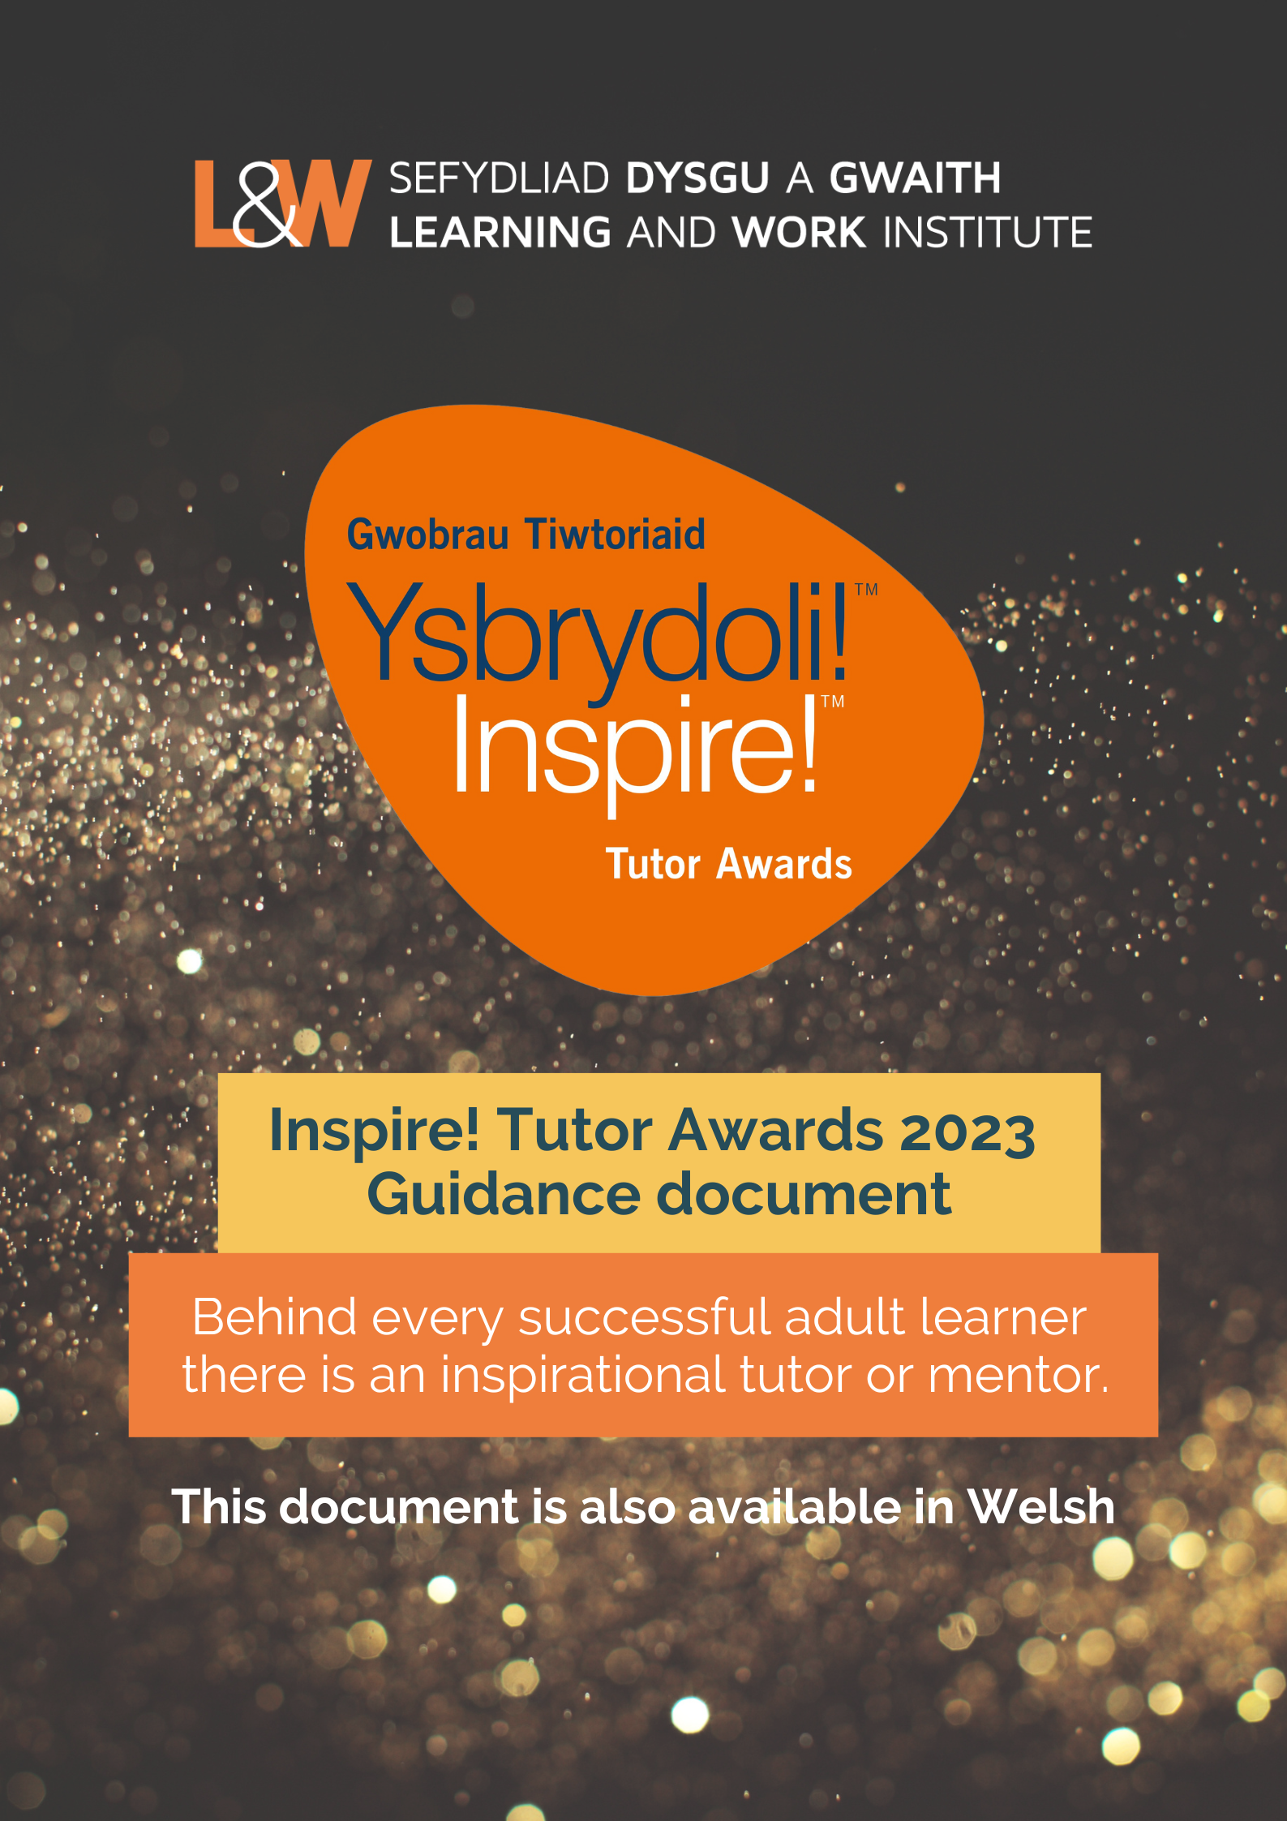
Click here to download this document in Welsh.

Inspire! Tutor Awards

Click here for the Welsh language Guidance document.
The annual Inspire! Tutor Awards recognise the valuable work of tutors and mentors in supporting lifelong learning across Wales.
The Inspire! Tutor Awards celebrate the outstanding effort and commitment made by tutors/mentors to help adult learners pursue their goals, because behind successful adult learners there are inspirational mentors and tutors.
We are inviting nominations on behalf of outstanding individuals whose commitment, knowledge and communication skills have given adults the encouragement to engage with learning and transform their lives.
The Awards Presentation will take place on 14 March 2023 at the Senedd.
The Inspire! Awards is a partnership involving Learning and Work Institute and Welsh Government, Universities Wales, NTFW, Colleges Wales, Adult Learning Wales Partnership.
What are we looking for?

We are looking for tutors/mentors who are ‘outstanding’ in their field and give ‘over and above’ what is expected of them.
Nominations should demonstrate achievements in at least two of the following areas:
- Developing the curriculum, creating new resources and materials
- Overcoming personal circumstances and / or working in challenging circumstances
- Contributing to widening access and building pathways to learning opportunities
- Inspiring learners to progress onto other courses or opportunities to learn
- Creating new partnerships or pathways into learning
- Developing innovative ways of supporting, teaching, or mentoring learners

Evidence of impact:
Your statements should demonstrate how the tutor/mentor has made an impact on the lives of their students.
You could focus on:
- Progression, attainment, and achievement
- Evidence of impact on the health and wellbeing of learners
- Describing how learners have used the skills they have developed to contribute to family/community life/civic society/the workplace or to transforming their own lives
- Additional testimonials from students, learners and colleagues is welcomed.
We are looking for tutors/mentors active in the following sectors or settings:
Tutor Awards categories

- Higher Education
- Further Education
- Workplace Setting
- Community Education
- Welsh for Adults
- School or other setting

A guide to submitting your nomination

- Entries are free and open to tutors/mentors living and working in Wales.
- You can nominate a tutor/mentor if you are a learner,
a provider or employer / work colleague, another tutor,
a learner or a member of the community.
- If you are a learner/community member you must obtain a statement of support for your nominee from someone who knows them in a professional capacity.
- All nominees must be aware that they are being nominated and should be willing to share their stories with the media.
- All those nominated will receive a certificate of achievement. This will be sent to the person identified on the form. Please ensure that the spelling of the nominee’s name is correct. This name will appear on the certificate.
- Your application will be judged on the information you provide on the nomination form, so please make sure you address the areas highlighted in the guidance.
The closing date for receipt of nominations:
Monday 16 January 2023.
No entries will be received after this date and there will be no extension.
If you need any assistance with your nomination form, please contact: inspire@learningandwork.org.uk

How does the selection process work?

- An independent panel of judges will assist with the selection of award winners.
- All award winners will be notified by the Learning and Work Institute by week commencing 13 February 2023. L&W will email you if there is any change in timescales.

How can I submit my nomination form?

By email:
Please email your completed form to: inspire@learningandwork.org.uk

The closing date for entries is Monday 16 January 2023.
The Inspire! Tutor Awards are coordinated by Learning and Work Institute and supported by Welsh Government, Colegau Cymru, NTFW, the National Centre for Learning Welsh, Universities Wales, and Adult Learning Partnership.
Learning and Work Institute Website | L&W Twitter | L&W Facebook

