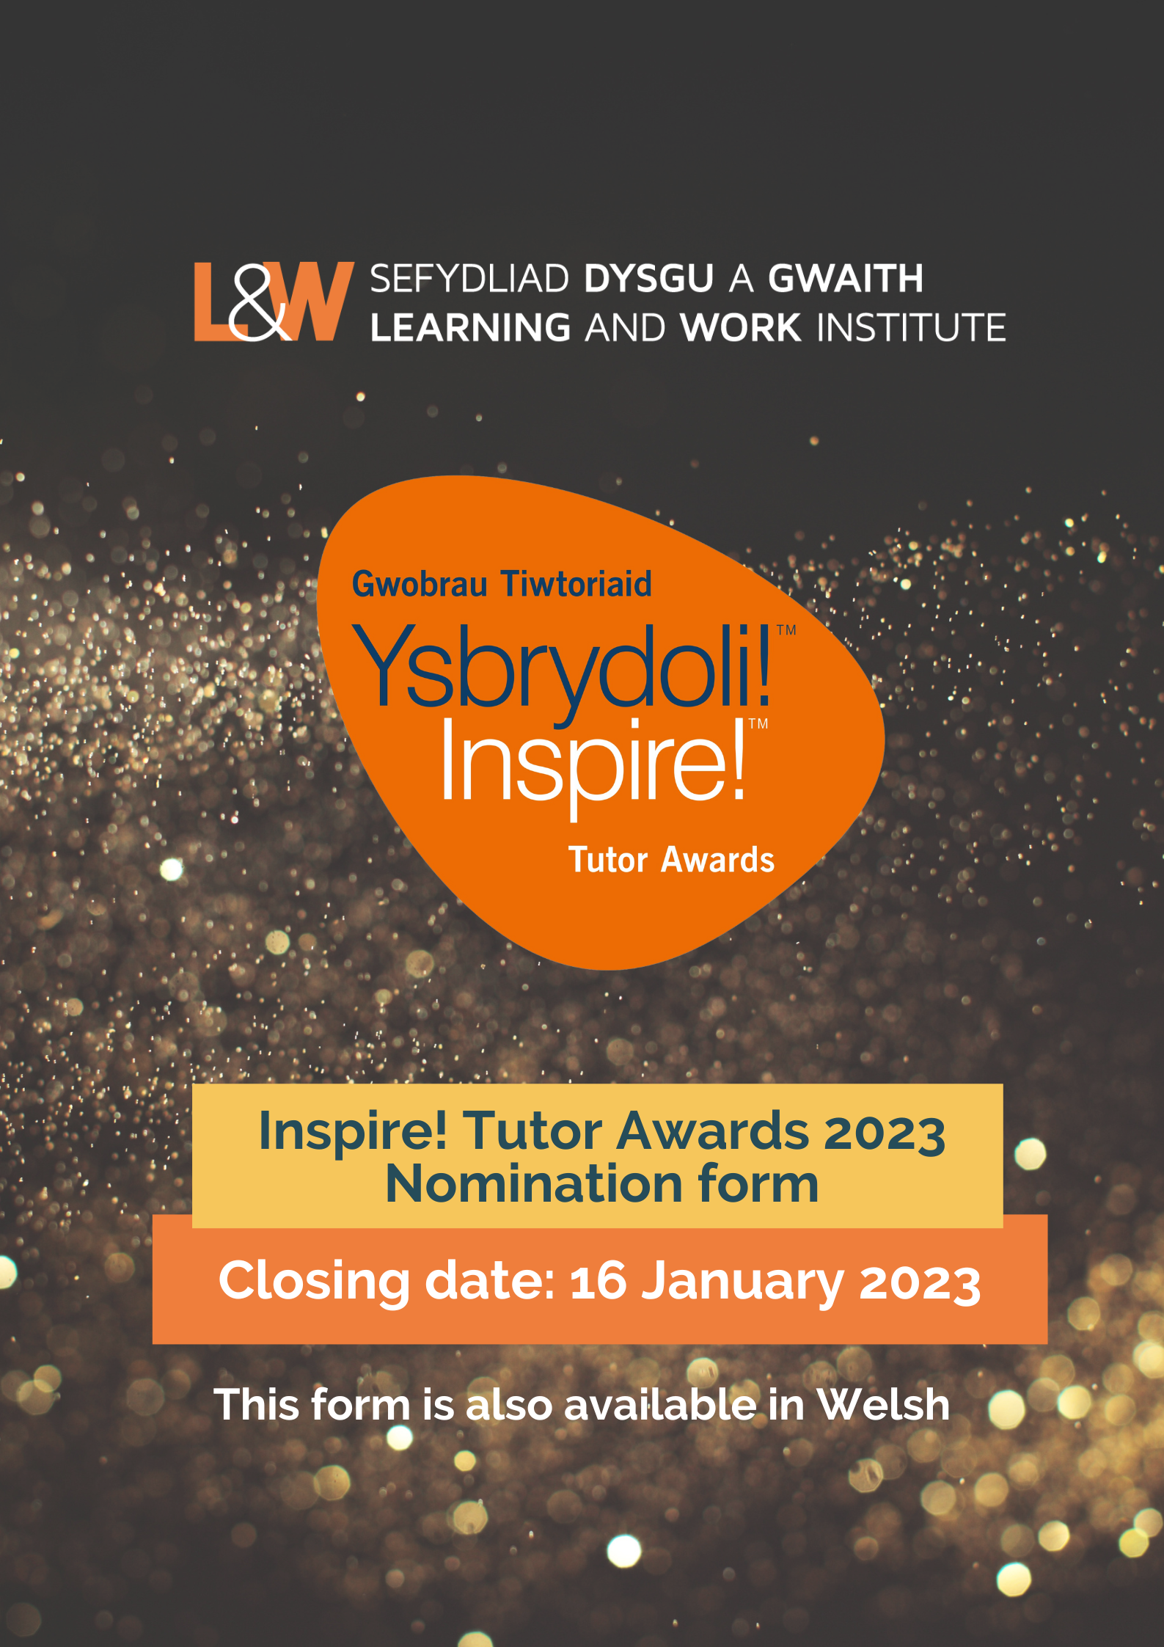
Click here for the Welsh language nomination form
Nominator details

1. Please enter your contact details:
First name / Surname
Organisation name
Organisation Address
Email
Daytime phone number
Mobile phone number
Tutor / Mentor Details
2. Please indicate your relationship to the tutor:
Student ☐ Union Learning Rep ☐
Employer ☐ Manager ☐
Colleague ☐ Friend / Relative ☐
Support Worker ☐

Other, please specify
3. Please enter the tutor/mentor contact details:
Full name
This is the name that will be used on your certificate
Organisation
Address line 1
Address line 2
Town / City
County
Postcode
Email
Daytime phone number
Mobile phone number
4. Please give the name of the tutor/mentor’s educational organisation or place of work:

5. Please describe the tutor/mentor’s employment status: (please tick those that apply)
Full-Time Employed ☐
Part-Time Employed ☐
Self-Employed ☐
Volunteer ☐
6. Please give the tutor / mentor’s job title if known:

7. Please indicate the sector or setting in which the nominee is working:
Sector | Please tick one box only
Higher Education sector | ☐
Further Education sector | ☐
Workplace setting | ☐
Community Education setting | ☐
Welsh for Adults setting | ☐
School or other setting | ☐
Other | ☐

Nominator statement
8. Nominator statement (please limit your statement to 500 words).

Why do you think the Tutor or Mentor deserves an Inspire! Award?

Please refer to the Guidance Document which gives some hints and tips to help with writing your statement.

This is your opportunity to tell us why your nominee deserves to win an award.

- What have they achieved?
- What impact do they make? What learning do they deliver? Have they developed innovative approaches to teaching and learning, created new pathways, built partnerships?
- If they have delivered innovation in learning or made a particular contribution to lifelong learning in Wales, please tell us more.

Tutor / Mentor statement
9. Tutor / Mentor statement (Please limit your statement to 500 words)
Please tell us about your achievements. Please refer to the Guidance Document which gives some hints and tips to help with writing your statement.
In your statement tell us:
What type of learning do you deliver? What have you achieved and what was the impact?
Have you developed innovative approaches to teaching and learning, created new pathways, and built partnerships? If so, please tell us how. What does tutoring / mentoring mean to you and what is your message to inspire adults back into learning?

Promoting your story - Press, PR and Marketing
The Inspire! Awards raise the profile of opportunities for lifelong learning. To do this we will want to share your story in press and media activities. We will plan to include you in press releases, through social and digital media. Within this process we will film and take photography to promote award winners. We will seek media coverage and interviews with the media for award winners.
Award winners will be invited to the Inspire! Tutor Awards Ceremony, at the Senedd on 14 March 2023. They may also be called to speak briefly about their experiences upon receiving their award.
10. If there are details about your story which you do not wish to be made public, please let us know in the box below, please be specific.

Your organisation’s marketing contact details
Inspire! Tutor award winners often generate local and national press or media interest. If your nominated Tutor or Mentor is selected for an award, Learning and Work Institute would like to liaise with your organisation’s Public Relations or Marketing Manager to publicise winners.
11. Please enter the contact details of your organisation’s Public Relations or Marketing manager (if applicable).
Full name
Email address
Daytime phone number
Mobile phone number

Tutor and Nominator Declaration
12. Please read the following statements carefully before signing the declarations. Only applications signed by both nominator and nominee will be accepted.
Nominator Declaration:
By submitting this form and ticking each of the boxes, I confirm that:
- I wish the named nominee to be nominated for an Inspire! Tutor Award 2023 ☐
- The information supplied in this form is correct to the best of my knowledge and that the statement is true and accurate ☐

- I give my consent for Learning and Work Institute to use the information in this form ☐

- I understand that if the named nominee is selected as a winner, I will be asked to take part in press and media activities ☐

- I have read this form and declaration carefully and fully understand its meaning ☐
Tutor / Mentor Declaration:
By submitting this form and ticking each of the boxes, I confirm that:
- I wish to be nominated for an Inspire! Tutor Award 2023. ☐

- The information supplied in this form is correct to the best of my knowledge and the statement is true and accurate. ☐

- I understand that if I am selected as a winner, my information provided here may be passed onto third parties including the press and media for publicity purposes only (please note that L&W will not share your contact details with anyone without your prior consent – the winner will also need to sign a GDPR consent. ☐

- I understand if I am selected as a winner, I will be asked to take part in press or media activities, this includes photography and filming and sharing my story through press releases for printed, social and digital media. ☐

- I understand that if my circumstances change and I no longer want to take part in any press and media, I will alert L&W at my earliest convenience. ☐

- I have read this form and the declaration carefully and fully understand its meaning. ☐
13. Would you like to be kept informed about Learning and Work Institute activities, events, and conferences?
Yes ☐ No ☐
Data Protection Statement
National Learning and Work Institute is committed to protecting and respecting your privacy and explaining what personal information we collect, why we collect it and how we use it.
The information you supply to us (other than credit and debit card details) will be retained by us on our secure cloud-based system and/or our in-house database, or for more sensitive data our secure server.
We take our responsibility with your personal data extremely seriously and aim to be transparent about how we handle, use and share (if applicable) your information.
The Learning and Work Institute is registered under the Data Protection Act 1998 (Registered Number Z7412510). Personal information supplied to the Learning and Work Institute will be stored securely and may be used in relation to the Learning and Work Institute’s work.
Full details of the purposes for which the Learning and Work Institute processes personal information is in our Data Protection Register entry, which can be found on the Information Commissioner’s website www.ico.gov.uk. At no time will we share personal information with other organisations without your express consent.
How can I submit my nomination form?
BY EMAIL
Please email your completed form to: inspire@learningandwork.org.uk
If you need any assistance with your nomination form, contact us on the email above.

The closing date for entries is Monday 16 January 2023
L&W Institute Website | L&W Twitter | L&W Facebook

