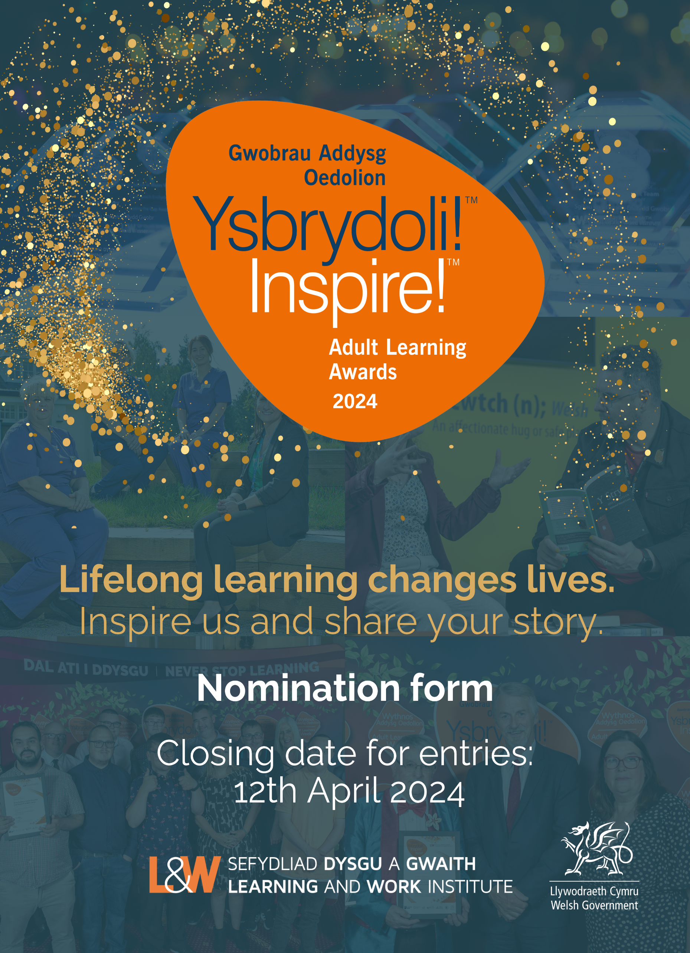
This document is available in Welsh.
Section 1
NOMINATOR DETAILS
1. Please enter your contact details:
First and last name
Organisation
Postal Address
Email
Daytime phone number
Mobile phone number
NOMINEE DETAILS
2. Are you nominating (please tick as appropriate):
An individual (go to question 3) | ☐
A project / organisation (go to question 5) | ☐
3. Please indicate your relationship to the person you are nominating

4. Please enter the contact details of the individual you are nominating.
Name (first and last name)
All nominees will a certificate of achievement, and this is the name that will appear. Please ensure the spelling is correct.
Organisation – if applicable
Region / County
Postal Address
Email
Daytime phone number
Mobile phone number
Your nominee’s place of learning
Is your nominee a Welsh speaker? If so, please indicate their level of Welsh proficiency.

5. Please enter the contact details for the project or organisation you are nominating.
Project / Organisation name
Every nominee receives a certificate of achievement, and this is the name that will appear. Please ensure the spelling is correct.
Contact name
Office Postal Address
Email
Daytime phone number
Mobile number

AWARD CATEGORIES
6. Please indicate the category you would like the nominee to be considered for.
You can find a description of award categories in the Guidance document.
Award Categories | Please tick one box only
Skills for Work Award | ☐
Young Adult Learner Award | ☐
Life Change & Progression Award | ☐
Ageing Well Award | ☐
Starting out – Welsh Beginner Award | ☐
Different Past: Shared Futures Award | ☐
Essential Skills for Life Award | ☐
Hywel Francis Award for Community Impact Award | ☐
Workplace Change Makers Award | ☐

Section 2
NOMINATOR STATEMENT
Please use this section to tell us about the individual, project, or organisation you are nominating. In writing your statements, please refer to the Inspire! Awards 2024 category and guidance note and our guidance on How to submit a successful nomination, as judges will use these when making their decisions.
Alternatively, if you would like to submit your nomination statements via video clip, you will need to complete Sections 1 and 3 of this nomination form and return it with your film. Films should be no longer than 5 minutes.
If you’d like to submit any further supporting statements or images, please submit them when you send in your completed nomination form.
Please refer to the category you are nominating for and write your nomination in relation to this:

If you are nominating an individual, you may wish to include:
- How learning has moved the nominee forward in life and what they intend to do in the future
- Details of the learning completed, progress made and any personal and professional achievement
- What is transformational about their learning journey and what has changed as a result
- Describe how learning has had a positive impact on the individual’s life, and on those around them – how have they developed and used their skills in their family, workplace, or community
If you are nominating a project, you may wish to include:
- Project objectives, details of the learning completed, progress made and any achievements
- Any innovative approaches to learning
- What is transformational about the project and what has changed as a result
- Explain how learning has had a positive impact on those involved, in the community or on those around them
- Impact and outcomes of the project or activity and any future plans for further development.
If you are nominating an organisation you may wish to include:
- The approach to workforce development – who is being targeted, how are they being reached
- The learning, skills, training, and development opportunities available to employees and the progression of the learners involved
- The contribution the learning has made to the organisation, including to the working environment and to staff (please provide any evidence)
- The partnership involved in delivering the learning activities
- Any particular response to new ways of working and delivering learning opportunities for example by supporting people and communities to switch to remote and blended learning

7. Please limit your nominator statement to 500 words. If you would like to submit additional information or photos, send them with this nomination form.

NOMINEE STATEMENT
If this nomination is for a project or organisation, you can use this section to collect statements from the people/partners or other stakeholders involved.
If you are nominating an individual, this section is for your nominee to complete. This is your opportunity to tell us about your learning experiences and how it has changed your life. Information supplied will benefit your nomination. Tell us what learning you have completed; are there any barriers you have had to overcome to get where you are now? What messages do you have to inspire others to return to learning and where do you think your journey will take you next?
8. Please limit your nominee statement to 500 words. If you would like to submit additional information or photos, send them with this nomination form.

Section 3
PRIVATE INFORMATION AND PUBLICTY
What happens if your nomination is shortlisted
Once nominations have been submitted, a panel of judges will go through the shortlisting process to select nominees in each category to go forward to an independent panel of judges. Please note that if your nomination is selected at the shortlisting stage - we may come back to you for further information.
What happens if your nomination is selected as an award winner
The Inspire! Awards raise the profile of opportunities for lifelong learning. If your nomination is selected as a winner, we will want to share your story in press and media activities.
PR activity will include:
- Press release stories to be published through social and digital media.
- A film and photography shots to promote award winners.
- Media coverage and interviews for award winners and possibly those who are shortlisted and selected as a case study.
- Nominators may be included in the film or photography.
We will always ask your permission before featuring your nominee’s story in any of our press or media activities.
9. If there are details in your nomination which you do not wish to be made public, please let us know in the box below. Please also indicate if you or any of those involved in this nomination do not wish to have photographs taken or be included in film and PR.

PRESS, PR, MARKETING AND CONTACT DETAILS
Inspire! Award winners often generate local and national press or media interest. If your nominee is selected for an Inspire! award, Learning and Work Institute would like to liaise with your PR or Marketing Manager.
10. Please enter the details of your PR or Marketing manager
Organisation Name
Contact Name
Email address
Daytime phone number
Mobile phone number
Organisation’s X (Twitter) handle | @
Organisation’s Facebook | @
Organisation’s Instagram Page | @

Section 4
NOMINEE AND NOMINATOR DECLARATION
Please read the following statements carefully before agreeing to and ticking each of the declarations. Only applications signed by both nominator and nominee will be accepted.
Nominator’s Declaration
By submitting this form and ticking the box, I confirm that:
- I wish the named person, project, or organisation to be nominated for an Inspire! Award 2024 | ☐
- The information supplied in this form is correct to the best of my knowledge and that the statement is true and accurate | ☐
- I give my consent for Learning and Work Institute to use the information in this form | ☐
- I understand that if the named person is selected as a winner, I may be asked to take part in press and media activities | ☐
- I have read this form and declaration carefully and fully understand its meaning | ☐
Nominee’s Declaration
By submitting this form and ticking the box, I / we confirm that:
- I / We wish to be nominated for an Inspire! Award 2024 | ☐
- The information supplied in this form is correct to the best of my / our knowledge and the statement is true and accurate | ☐
- I / We understand if I am / we are selected as a winner, I/we will be asked to take part in press or media activities, this includes having my / our picture taken, taking part in a film, and having my / our story included in Inspire! Awards materials such as a press release, social and digital media for inspire! Award promotional materials – and I will be asked to sign a GDPR consent for these. | ☐
- I understand that if my circumstances change and I can no longer take part in any press and media, I will alert Learning and Work Institute at my earliest convenience | ☐
- I / We have read this form and declaration carefully and fully understand its meaning | ☐

11. We would like to keep you informed by email about further Learning and Work Institute events, activities, future award nominations and our campaigning work in Wales. If you are happy for us to contact you, please tick the box below.
Yes ☐
If you would like to update your preferences, please contact: enquiries@learningandwork.org.uk
Learning and Work Institute will only use personal data in accordance with the terms of consent given by the individual or group.
DATA PROTECTION STATEMENT
The Learning and Work Institute is registered under the Data Protection Act 1998 (Registered Number Z7412510). Personal information supplied to the Learning and Work Institute will be stored securely and may be used in relation to the Learning and Work Institute’s work.
Full details of the purposes for which the Learning and Work Institute processes personal information is in our Data Protection Register entry, which can be found on the Information Commissioner’s website www.ico.org.uk . At no time will we share personal information with other organisations without your express consent.

HOW TO SUBMIT YOUR NOMINATION FORM
Please email your completed form to:
inspire@learningandwork.org.uk
Alternatively, you may submit your completed nomination form by post:
Learning and Work Institute, 7 Coopers Yard, Cardiff, CF10 5NB
The closing date for entries is Friday 12th April 2024

